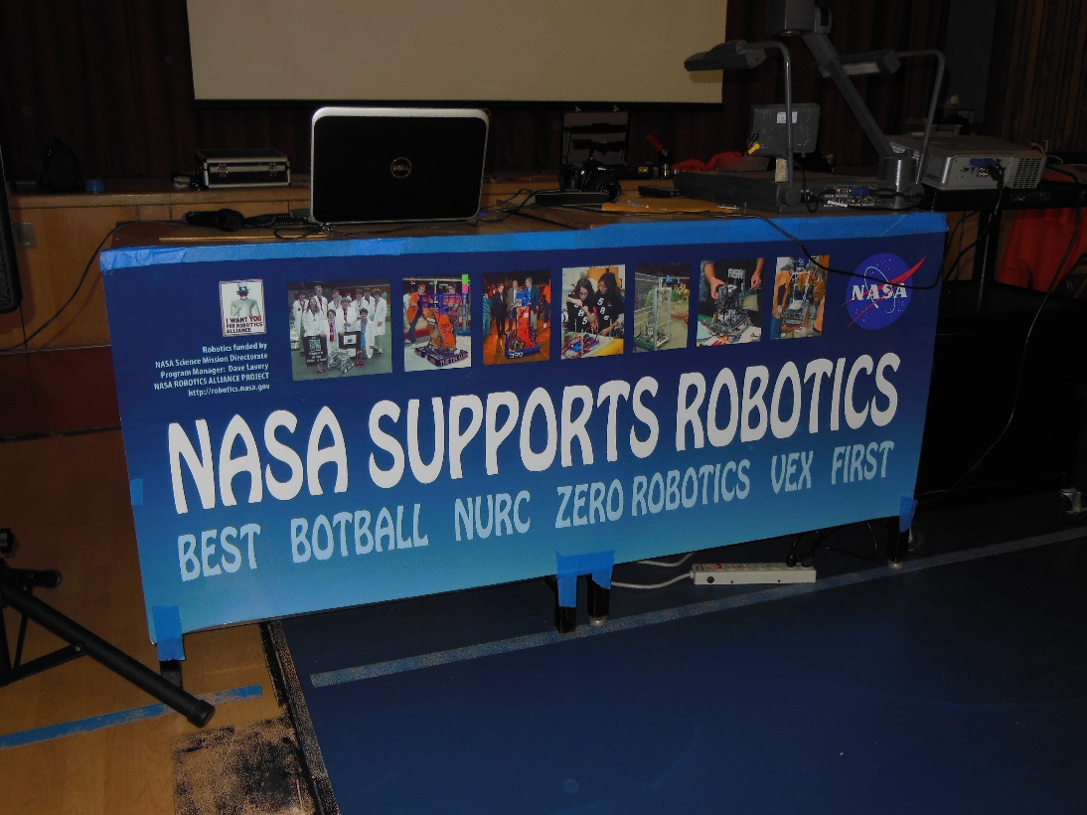
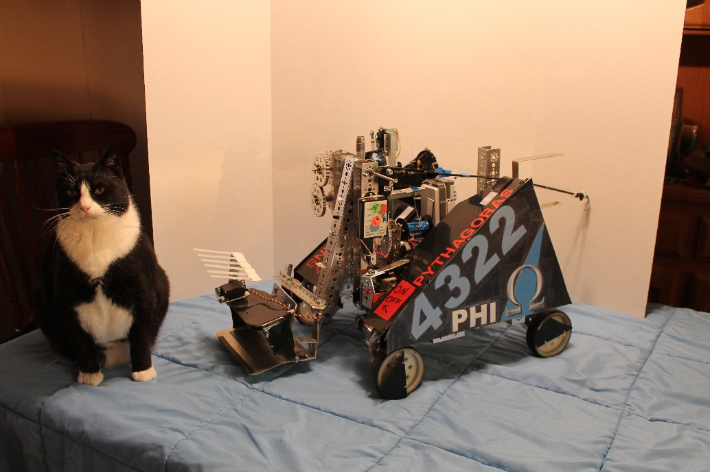
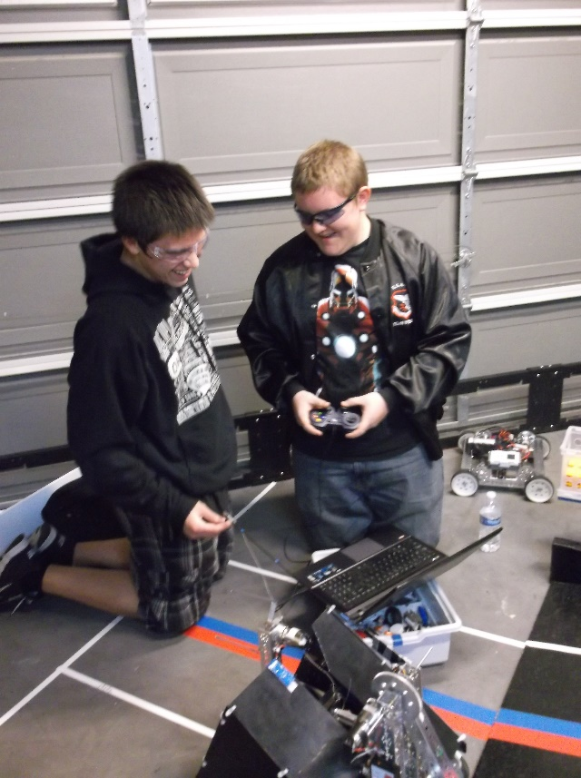
Promote Award Video Entry:

PROMOTE VIDEO

This year Phi Robotics decided to make an entry for the Promote Award. Both Phi Alpha and Phi Omega collaborated to make a video submission for the award. The teams came together and submitted their answers to this year’s challenge- Why I Chose FIRST. Then we compiled those answers and combined them into a 60-second video.
We wrote several drafts of the script we used for the video. The final draft is included below:

Person A - Why First?
Person B - Why First?
Person C - Why First?
Person D - Why First?

-Screen shows a collage of "Why First?"
- Screen shows a large "WHY FIRST?"

Luke - I chose FIRST because it's a way to learn new things ()
Kaitlin - to challenge ourselves ()
Hanna - to give us head starts to our futures ()

Mike - I chose FIRST because it builds teamwork and cooperation ()
Person B – It brings together new friends (Cole)
Person C – It provides a way to interact with others who share our interests (Sergei)

Person A -I chose FIRST because it teaches responsibility (Becky)
Person B – It teaches us to act independently and take initiative (Holly)
Person C – how to become both good leaders and good followers (Jonathan)
Person D – to learn to sacrifice for the good of others (Eddie)
Person E – to learn diligence, confidence, and determination (Holly)
Person F – and to become more creative (Cici)

Person A - I chose FIRST because it's a way to share gracious professionalism (Mike)
Person B - to encourage others (Scott)
Person C - to help others (Becky)

Person A - I chose FIRST because it's a way for us to reach out to the community (Kaitlin)
Person B - to participate in and host events (Kayla)
Person C - to partake in healthy competition (Hanna)
All- I chose FIRST because it’s a way to have fun!
*credits*

